The issue was caused because of an extra **cb();** line of code in DocumentProcessor.js file (*This was missed in the deployment document*). This was causing the DocumentProcessor service to return control to the DocumentManagerController before the processing was complete. I have fixed this.

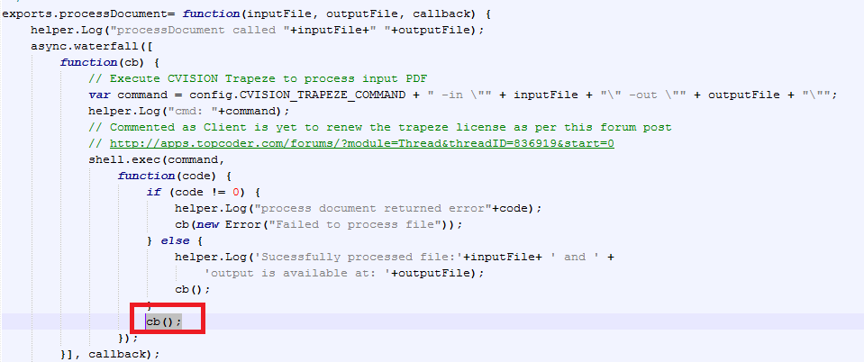

Please use the fixed code and move file following files in the root folder of the fix:

1. Move DocumentManagerController.js to document_manager/document Processor/controllers folder
2. Move DocumentProcessor.js to document_manager/document Processor/services folder

The following is the screenshot of the successful execution:

Document Processor:

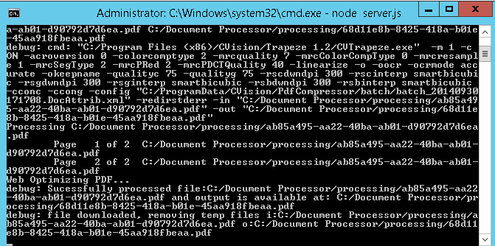

Postman REST client:

